Subject: 2 weeks to submit your application to speak for the 12th ICT4D Conference
12th ICT4D Conference, April 21 - 23, 2020, Abuja, Nigeria

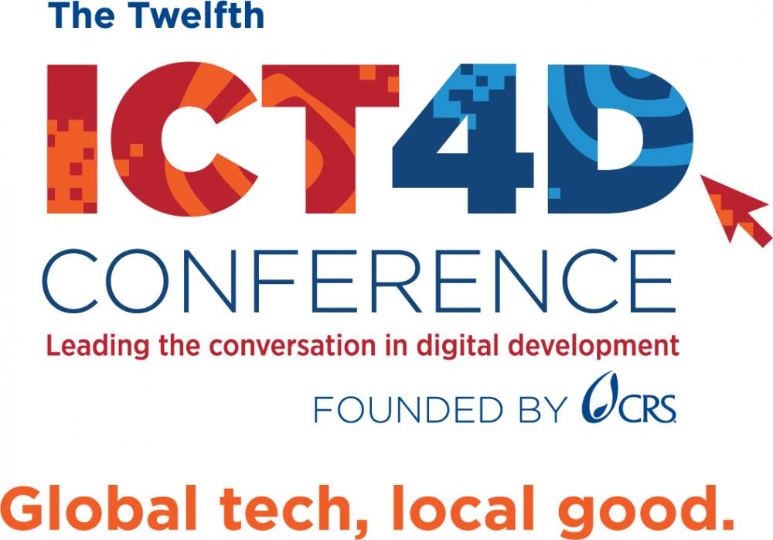

LESS THAN TWO WEEKS LEFT TO APPLY TO SPEAK - DON'T MISS OUT!

HAVE YOU SUBMITTED YOUR APPLICATION YET?

Dear Colleague,
With next year’s 12th ICT4D Conference confirmed to take place on April 21 – 23 in Abuja, Nigeria - please note that there are now only just under 2 weeks for you to submit your speaker application. Deadline November 30, 2019. The event is an excellent platform to emphasize your position as a visionary ICT leader and gives you the opportunity to join 800+ attendees for 3 days of networking and knowledge sharing around the use of digital technology for development and humanitarian aid. Check out the 2020 conference tracks here.
If you have already started your application, be sure to continue before the deadline and submit.

Apply to Speak

Why hundreds of development professionals have attended the foremost global digital development conference:
- Make an impact – engage and collaborate with colleagues from civil society, public and private sectors to promote sustainable change and build community and organizational capacity
- Multisectoral and cross functional learning options to help you accelerate progress toward the SDGs and Principles for Digital Development
- Develop and enhance your ICT4D skills, tools and resources
- Actively participate in high level plenary sessions to technical discussion groups and training workshops
- Take away your own action plan to help you get digital technologies to program participants

Interested in sponsoring or exhibiting at the 2020 ICT4D Conference? Contact Sonja Ruetzel today for the full opportunities available.
We look forward to welcoming you to the 12th ICT4D Conference next year,
Kind regards,
The ICT4D Conference Team

Sent to: _t.e.s.t_@example.com
ICT4D Conference, led by Catholic Relief Services, 228 W. Lexington St, Baltimore, Maryland 21201-3443, United States

